**Performance Load:**

**The greater the effort to accomplish a task, the less likely the task will be accomplished successfully.**

The tools and systems that surround a learner can either help or hinder learning. This truth is captured in the design principle of Performance load, which states that the greater the effort to accomplish a task, the less likely the task will be accomplished successfully. By stripping away unnecessary obstacles and information we can increase the learner’s likelihood of completing the desired learning task. Performance load can be broken into two categories; Cognitive, dealing with mental activity, and Kinematic, which concerns physical activity. For example, a learning workbook with hard to read font, poorly worded instructions, and unclear objectives can tax the student’s mental reserves independent of what’s being learned or tested. This type of cognitive load decreases the student’s likelihood of completing the workbook, hinders learning, and makes evaluation difficult. In the same vein, a software-based learning program whose user interface feels unresponsive and unwieldy while requiring multiple clicks to navigate seemingly simple tasks creates an unnecessary Kinematic load, which may frustrate the user, sap their attention, and ultimately decrease the program’s effectiveness. Designers and educators who remove distractions and barriers can reduce the performance load experienced by their students, thereby freeing up valuable mental and physical resources which can then be channeled to attention and engagement towards the desired learning outcome.

Performance load is important to manage because humans can truly focus their attention on only one thing at a time, and attention is the single most valuable commodity the designer or educator can seek to capture and hold. It is the filter that allows for concentration and is central to [human learning](http://parisinnovationreview.com/articles-en/did-neuroscience-find-the-secrets-of-learning). We only have so many calories to give at any point in time, and learning is best served when as many calories as possible are spent, or conserved, towards the desired outcome. By removing distraction, extra steps, and extraneous processes, we free up attention and allow the learner to focus on the information or actions that matter most. Doing so helps the educator to align with [UDL](http://udlguidelines.cast.org/) principles of Recruiting Interest, Perception, and Comprehension. We see these benefits throughout the world of design in concepts like chunking, cost-benefit, and Pareto’s principle, where salient information and actions pay the greatest dividends. We can work to decrease Performance load by focusing on a few key situations: when the material is new or complex, when presenting or demonstrating new information, and when constructing mental schemas to help navigate future scenarios. See below for five examples.

**Reduce extraneous information**

PowerPoint tends to be the consumate whipping boy for extraneous information, and for good reason. Often It's because there's too much text on a slide. On the left, we see a well-meaning example where the text is not necessarily overbearing but there's simply too much imagery going on, and it contains clipart that may add levity but also adds distraction. On the right, we see a simplified and cleaned up version that only contains the relevant information for the slide. Here we reduce performance load by destributing content across more slides, and reduce the volume of content on any given slide.

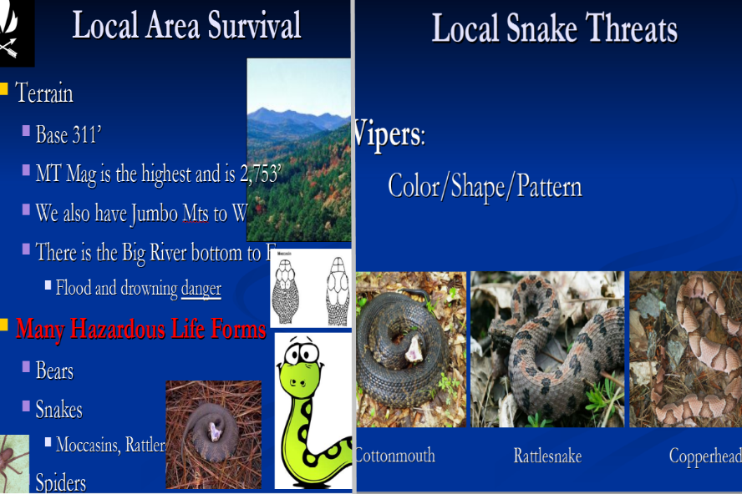

**Chunk and simplify**

When giving instructions for a new system, or complicated task, the temptation can be to cover every possible scenario. Small manageable steps and simplification can be the key. This example does not do that. It helps students understand how to conduct an analysis of variance using statistical modeling software, [SPSS](https://www.ibm.com/products/spss-statistics?p1=Search&p4=p50436903114&p5=e&cm_mmc=Search_Bing-_-1S_1S-_-WW_NA-_-ibm%20statistics%20spss_e&cm_mmca7=71700000061022197&cm_mmca8=kwd-81089125487726:loc-71138&cm_mmca9=CJjMr9KZ8-oCFU2jfgod39wP1A&cm_mmca10=81089043990886&cm_mmca11=e&gclid=CJjMr9KZ8-oCFU2jfgod39wP1A&gclsrc=ds). It uses concise text and step by step imagery to reduce information overload and help the student grasp a process that may at first feel overwhelming.

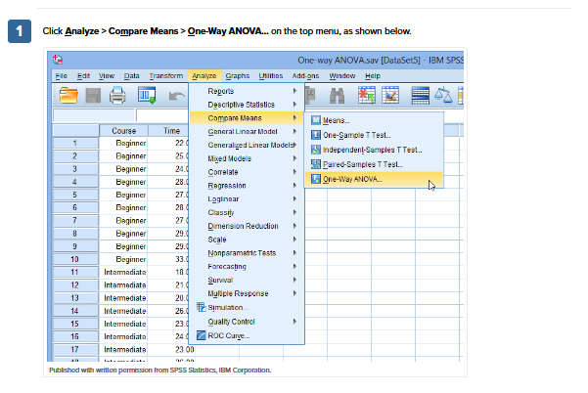

**Shape the environment**

Sometimes a teacher or facilitator may feel like flooding the learning environment with useful tools and visualizations will help the student. When in fact being surrounded by so many stimuli may work against the student's ability to focus on a given task. Here we see an example of a comfortable classroom that takes a more minimalist approach thereby reducing extraneous performance load and allowing the student to pay attention to relevant content. Some may see it as stark, but it helps to minimize sensory overload.

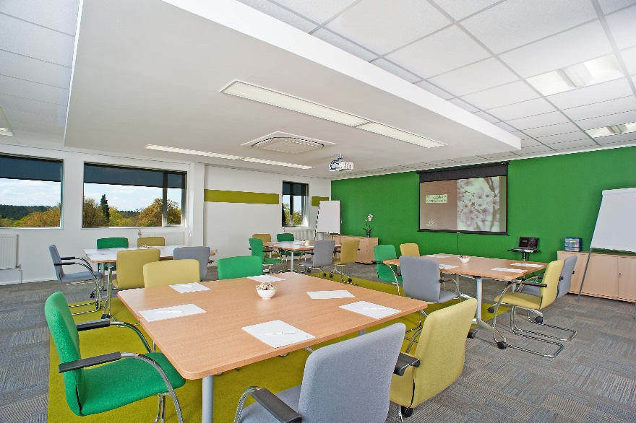

**Intrinsically difficult**

Certain new tasks can feel so overwhelming that it makes the learners head spin, and it's all they can do to focus on the mechanics of getting through it. This is an example of intrinsic performance load and learning to drive falls under this category for many. We can help reduce intrinsic performance load via step-by-step processes containing introductory material, discussion, simulations, and practice.



**Step by step-** bonus

Learning to dance or learning a new step can also seem overwhelming at first. Dancing, much like driving, carries a kinematic load due to the physical action required. By breaking information into small manageable steps, using visualization and feel, we can help the learner move effortlessly through the new task be it a dance step or algebraic equation.

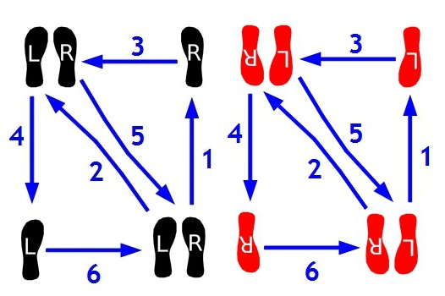

**Offset with Germane**

Another type of performance load is germane cognitive load and is different from the other examples. This type of load is desirable because it assists the learner in developing a mental schema to understand a new concept and helps to offset other types of performance load. FOIL is a prime example of germane cognitive load by using a mnemonic device to develop a mental picture of how to deconstruct a particular problem type. Use [FOIL](https://www.freemathhelp.com/using-foil.html#:~:text=That%27s%20where%20%20we%20use%20the%20FOIL%20method.,a%20specific%20order%3A%20%20first%2C%20outside%2C%20inside%2C%20last.) to multiply two binomials in a specific order: first, outside, inside, last.

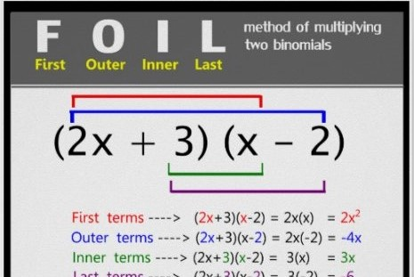

Duane Gregory - WTAMU course 6310 - Summer II - 2020